* In the last blog, we have seen the Introduction of Hypothesis with the definition and example and some terminologies such as Null and Alternative Hypothesis i.e. H0 & H1, Simple and Composite Hypothesis which can easily be understood by notations than the definitions. Now

*Continuing the Terminologies*.....

* ***Errors*** :- The decision to accept or reject the Null Hypothesis H0 is made on the basis of the information supplied by the observed sample observation. The conclusion drawn on the basis of the particular sample may not always be true in respect to the population. The 4 possible situations that arise in any test procedure are given in the following table.

Decision from sample

|  |  |  |
| --- | --- | --- |
|  | **Reject H0** | **Accept H0** |
| **H0 is True** | Wrong (**Type I**) | Correct |
| **H1 is True** | Correct | Wrong (**Type II**) |

From the above table, it is obvious that in any testing problem we are liable to commit the types of error.

1. ***Type I Error*** :- The Error of rejecting H0 or accepting H1 when H0 is true is called *Type I Error*.

The probability of *Type I Error* is denoted by “α”.Thus

α = P[Type I Error]

α = P[Rejecting H0 | H0 is True]

Symbolically

α = P[C | H0]

1. ***Type II Error*** :- The Error of accepting H0 when H0 is false or H1 is true is called *Type II Error*.

The probability of *Type II Error* is denoted by “β”.Thus

β = P[Type II Error]

β = P[Accepting H0 | H1 is True]

Symbolically

β = P[C’ | H0]

Let us understand it by an example,

If we reject a good lot then we are making *Type I Error* and its probability is α. Similarly if we accept a defected lot then we are making *Type II Error* and its probability is β.

By understanding the above definitions and example, it is obvious that *Type II Error* is more dangerous than *Type I Error*.

**Remark** :- In Quality Control terminologies, α and β are termed as “Producer’s Risk” and “Consumer’s Risk” respectively.

* ***Power of the test*** :- The probability that the test correctly rejects the Null Hypothesis (H0) when a specific Alternative Hypothesis (H1) is true is called the *Power of the Test*. It represents the chances of a true positive detection. i.e. as the *Power of the Test* increases, the probability of making a Type II Error (β) decreases.

The Power of the Test is denoted by (1- β) or Iβ {Iβ = Script Beta}

It can be expressed as a function of true parameter say, θ.

* ***Level of Significance*** :- The *Level of Significance* may be defined as the probability of Type I Error which we are ready to tolerate in making a decision about H0.

α = P[Rejecting H0 | H0 is True]

It is our endeavor to test which minimizes both types of errors. But it is obvious that for a given set of observations, both the errors cannot be controlled simultaneously. Hence it is a general practice to assign a bound to Type I Error and to minimize Type II Error.

* ***Size of the Test*** :- Practically, it is numerically the same as the *Level of Significance*. And it is defined as the size of the *Critical Region*.
* ***Critical Region*** :- Let x1, x2, ….. , xn be the sample observations denoted by O. All the values of O will be aggregate of a sample and they constitute a space, which is denoted by S.

Since the sample values x1, x2, ….. , xn  can be taken as a point in n-dimensional space and see whether this point lies within this region or outside this region. We divide the whole sample space in 2 disjoint parts ω and ω’ or C and C’. The null hypothesis H0 is rejected if the observed sample point falls in C and if it falls in C’ we reject H1 and accept H1. In simple words, C can be termed as rejection region and C’ can be termed as acceptance region.

*Coming towards the* *definition*…..

**Definition** :- The region of rejection of H0 when H0 is true is that region of the outcome set where H0 is rejected if the sample point falls in that region and is called *Critical Region*. The size of the *Critical* *Region* is α, the probability of Type I Error.

**Two sided region**

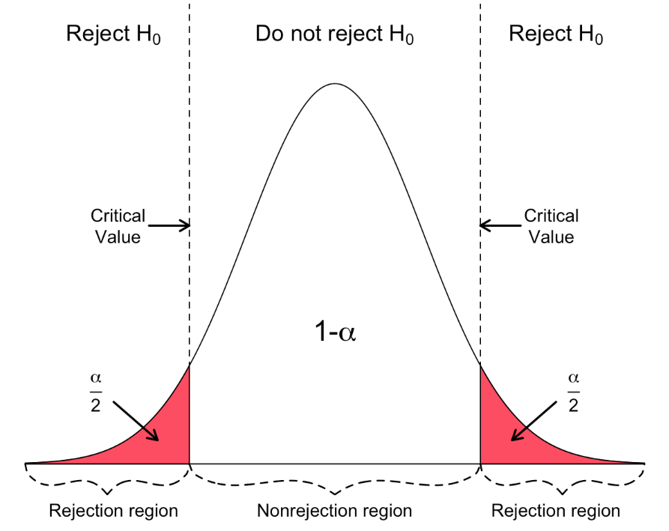

The above diagram has two sided *Critical Region* or Rejection Regionwhich is colored as red. As we know that the probability of *Critical Region* is α. So the probability of both side region is divided into 2 parts i.e. α/2. And the probability of the remaining part i.e. *Acceptance Region* is 1-α. And the point which divides the Critical Region and Acceptance Region is called “Critical Value”.

**One sided region**

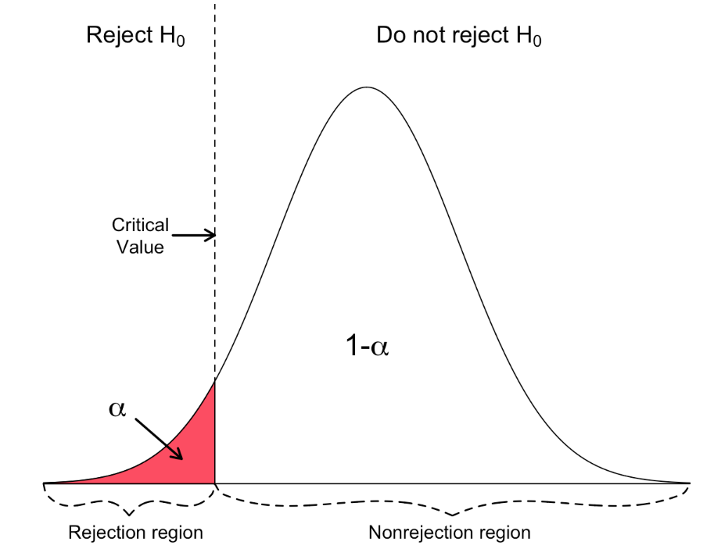 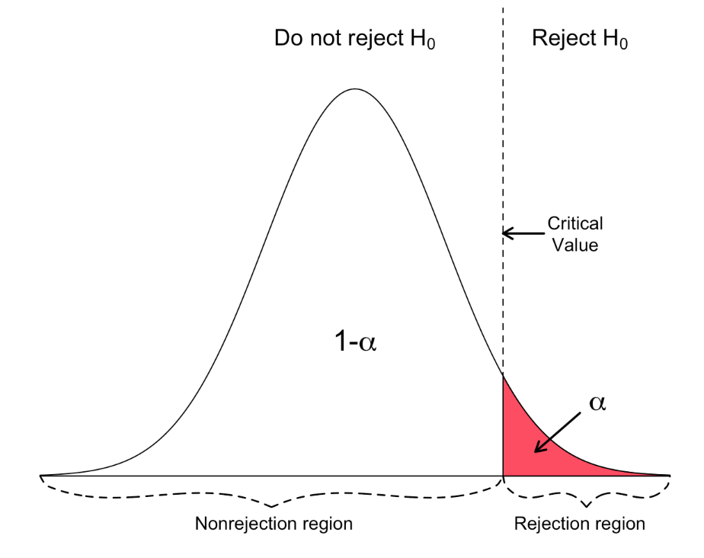

The above 2 diagrams are one sided i.e. left and right. The red colored region which is beyond the Critical Value is the *Critical Region* with probability α and the remaining part is *Acceptance Region* with probability 1-α.

* ***Best Critical Region*** :- A *Critical Region* of size α which minimizes β among all the critical regions which does not exceed α is called the *Best Critical Region*.